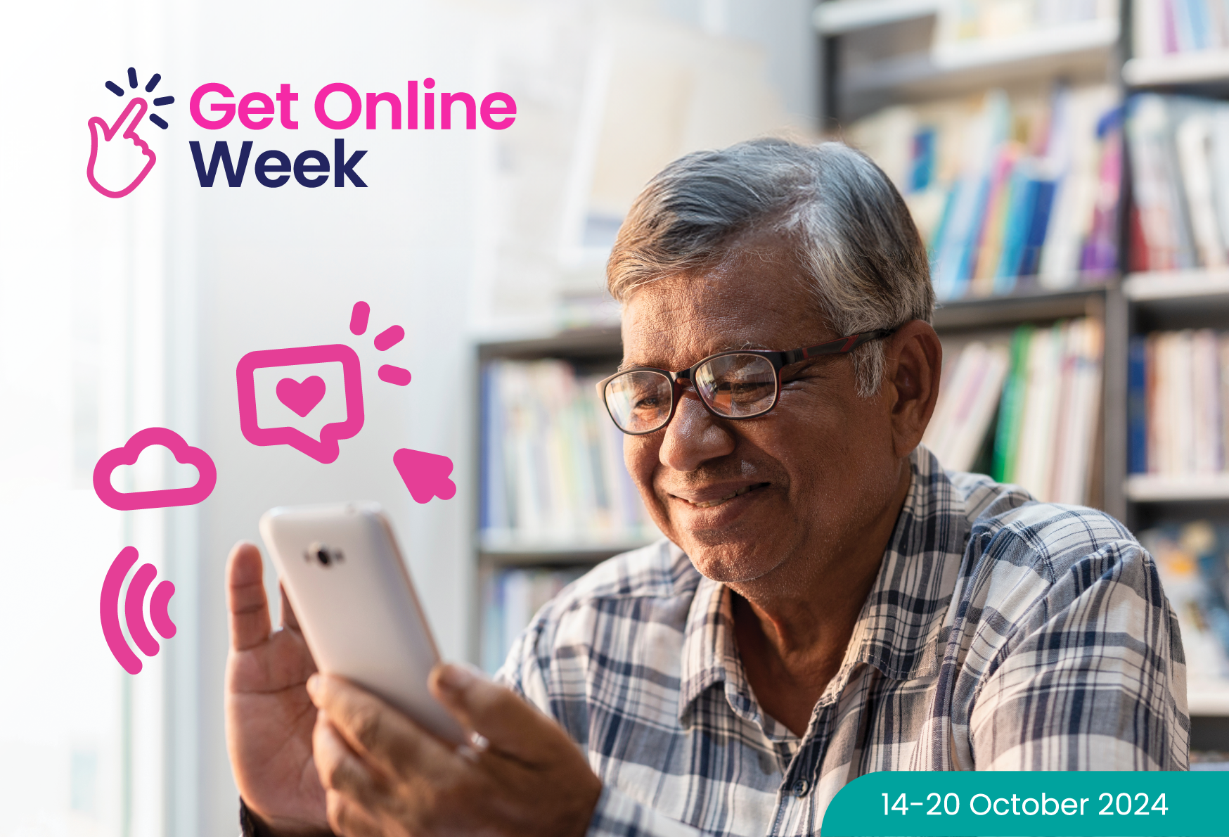

Get free and friendly  
help to get online safely and confidently

{ADD your event details here}

